Tableau visualizations

**Qn 1: The number of calls received by the fire department on a specific date**

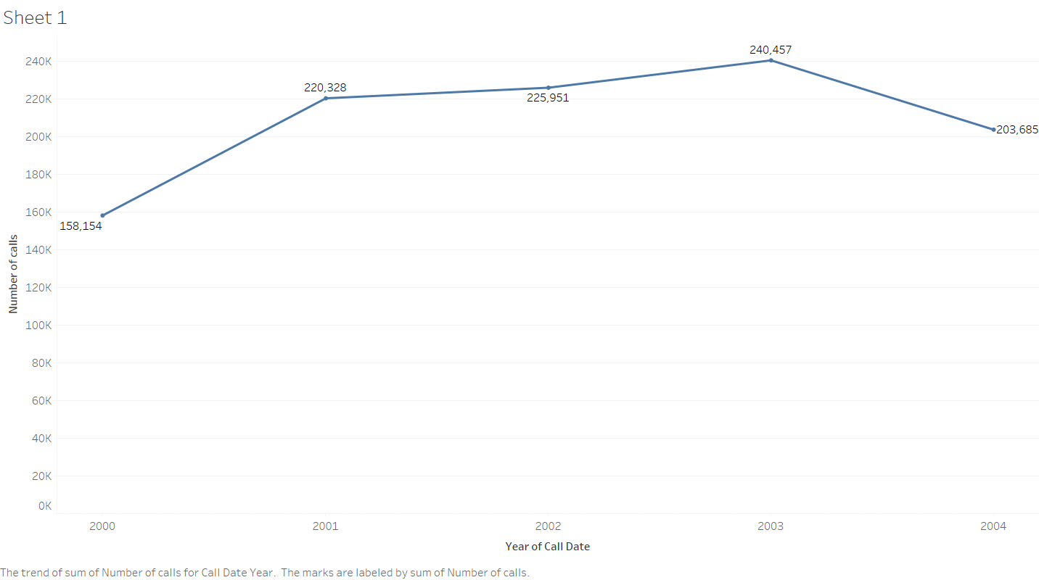

**Qn 2: The number of incidents that happened in a particular zip code**

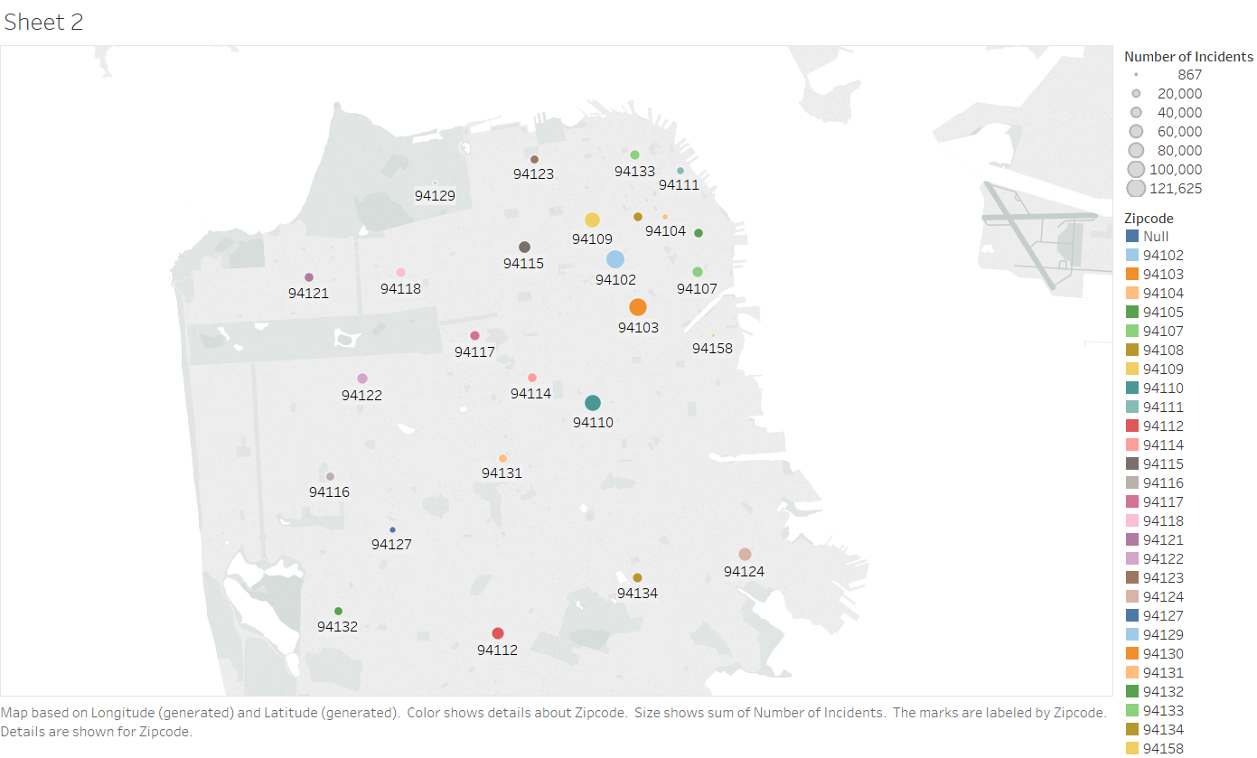

**Qn 3: What is the trend of each incident over the years**

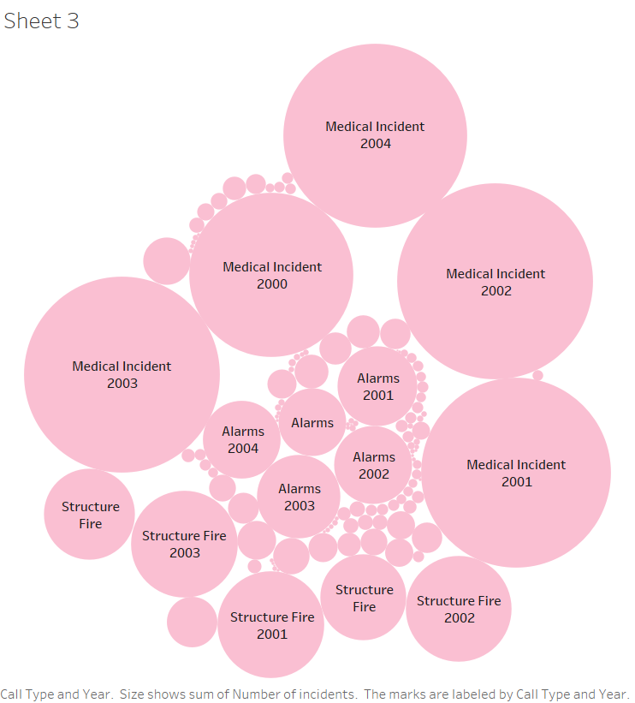

**Qn 4: The number of high priority and low priority calls received per day**

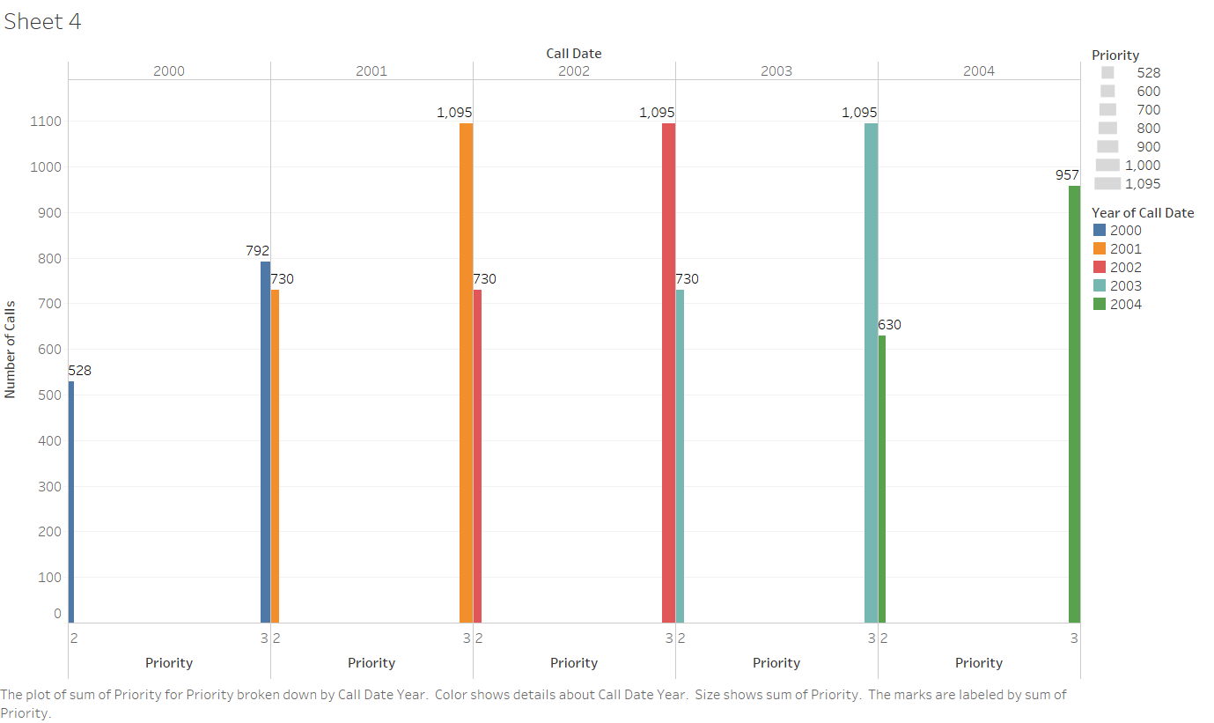

**Qn 5: Intensity of each incident over the geospatial locations in San Francisco**

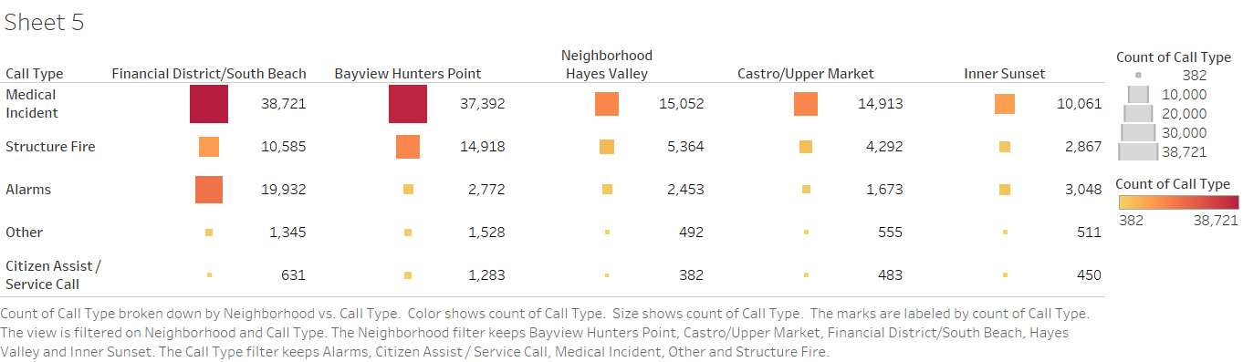

**Qn 6: Number of unit types dispatched for each incident during the year 2000 to 2004**

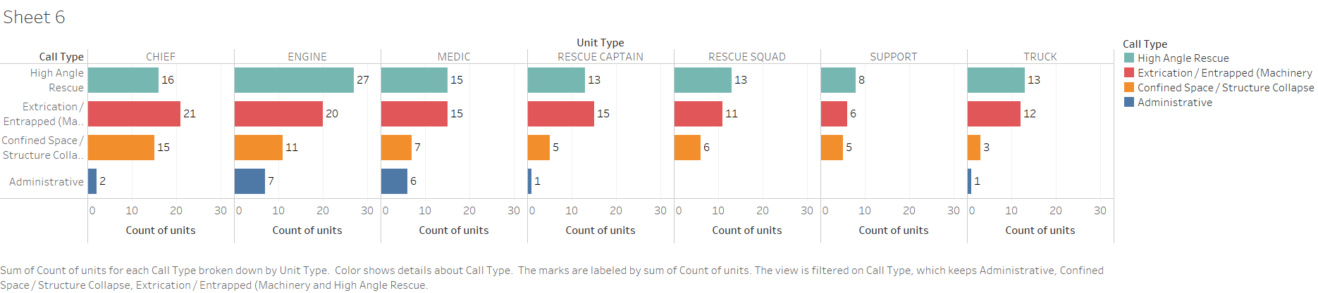

**Qn 7: The top 10 of incidents that happened over the years**

